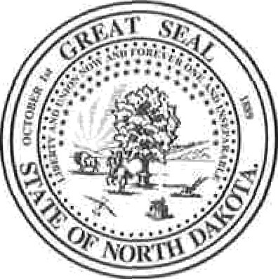
NORTH DAKOTA STATE BOARD OF COSMETOLOGY
4719 SHELBURNE ST. SUITE 1
BISMARCK, ND 58503
TELEPHONE (701) 224-9800

The North Dakota State Board of Cosmetology held a special meeting on Wednesday, January 3, 2024 11:30 a.m. at the board office, 4719 Shelburne St., Suite 1, Bismarck, N.D.

Agenda
- Legislative questionnaire
Emily made a motion for Holly to forward Legislative questionaire. Teresa seconded that motion. All voting: Emily (y), Miranda (y), Teresa (y), D’Arlyn (y). Motion carried.
- Kayle Duckwood reciprocity application
Teresa made a motion to have Kayle Duckworth take an additional 100 hours in Manicuring and Esthetics and an additional 76 hours to complete the requirements of 1500 hours and apply for the national theory exam, and North Dakota State Law and Rules and Regulations. Miranda seconded that motion. All Voting: Emily (y), Miranda (y), Teresa (y), D’Arlyn (y). Motion carried.
- Administrative Admin position
Maureen made a motion to create a permanent position of Admininstrative Assistant Emily seconded that motion and offer it to Lisel. All voting: Emily (y), Miranda (y), Maureen (y), Teresa (y), D’Arlyn (y). Motion carried.
- Inspector positions
D’Arlyn made a motion to approve inspector job decriotion. Maureen seconded that motion. All Voting: Emily (y), Miranda (y), Maureen (y), Teresa (y), D’Arlyn (y). Motion carried.
Maureen made a motion to hire at $22.12 per hour plus benefit package for full time and part time inspector position. Emily seconded that motion. All voting: Emily (y), Miranda (y), Maureen (y), Teresa (y), D’Arlyn (y). Motion carried.
Teresa made a motion to have Holly make correction in job posting and send it to Courtney prior to next board meeting. Emily seconded that motion. All voting: Emily (y), Miranda (y), Maureen (y), Teresa (y), D’Arlyn (y). Motion carried.

Maureen made a motion to adjourn the meeting. All voting 5 (yes), no (0). Meeting adjourment at 12:54pm.

